1. PROGRAM TO READ DATA AND PRINT DATA IN A ARRAY

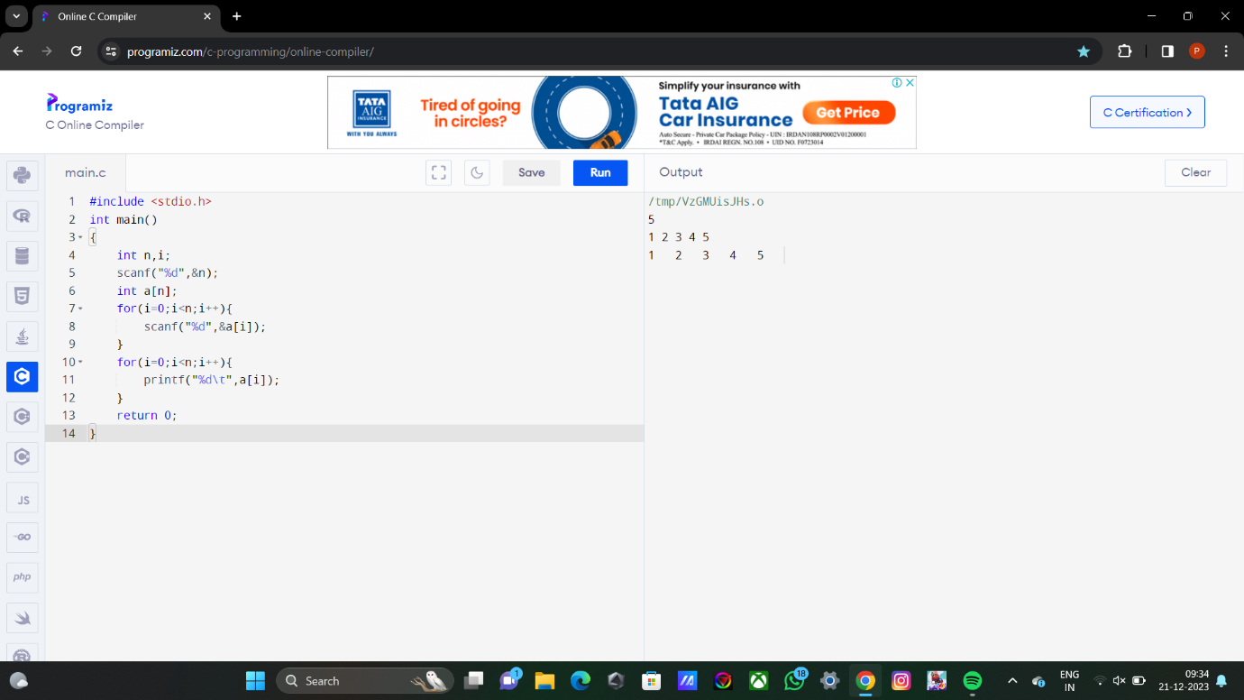

1. SUM OF NUMBERS IN A ARRAY

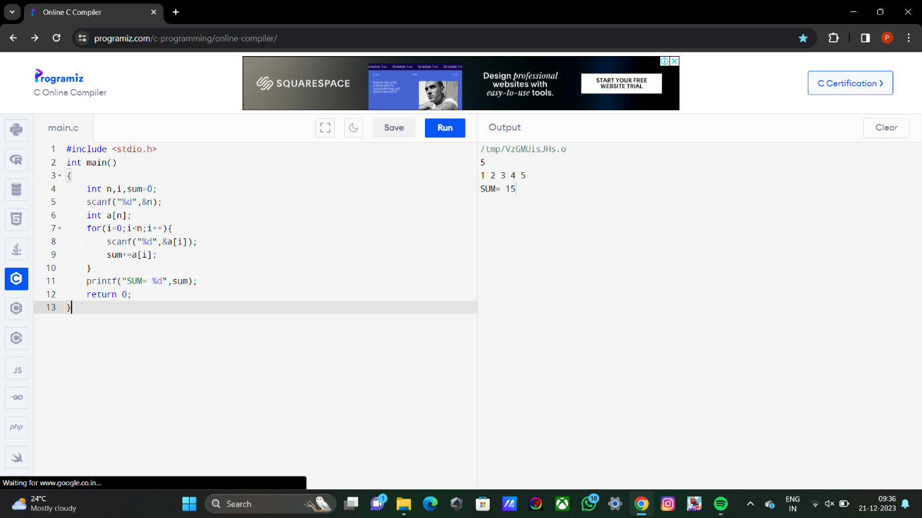

1. TO FIND COUNT OF ODD AND EVEN NUMBERS IN A GIVEN ARRAY.

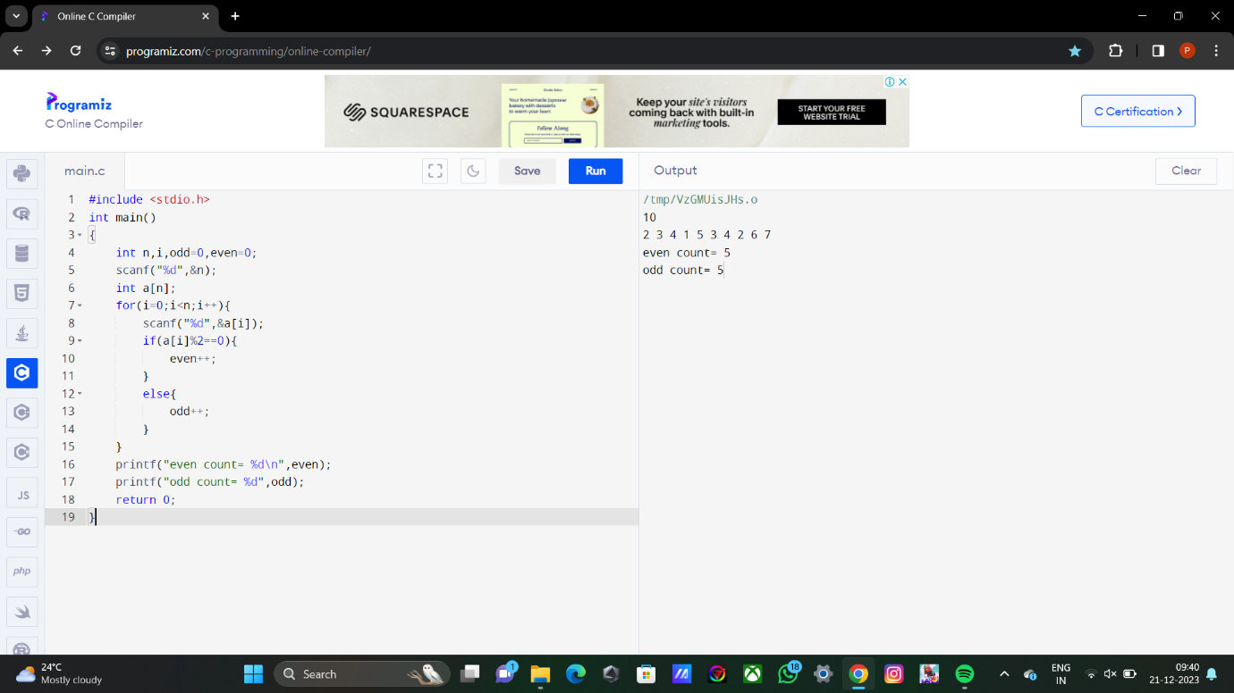

4. LINEAR SEARCH

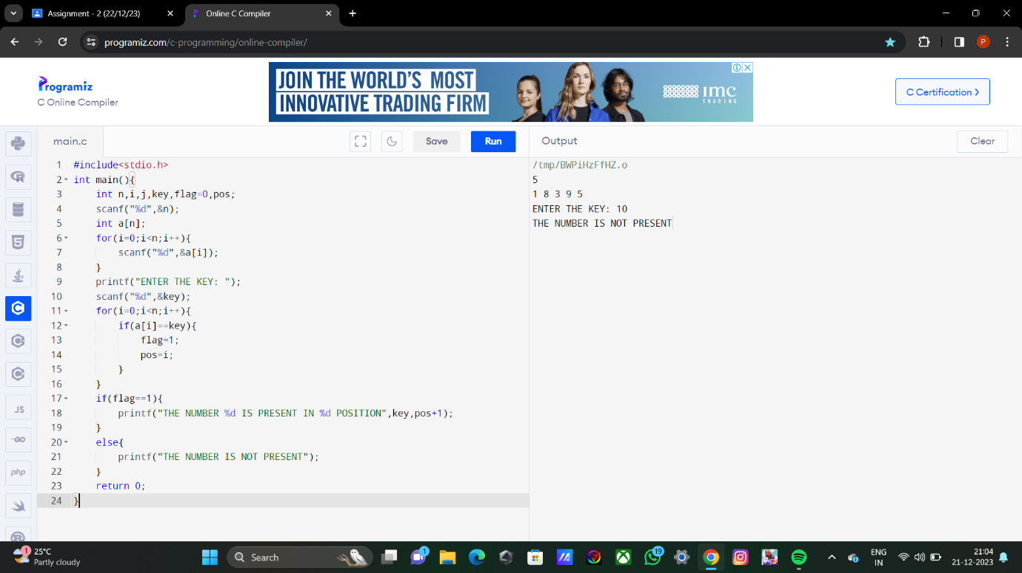

5. BINARY SEARCH

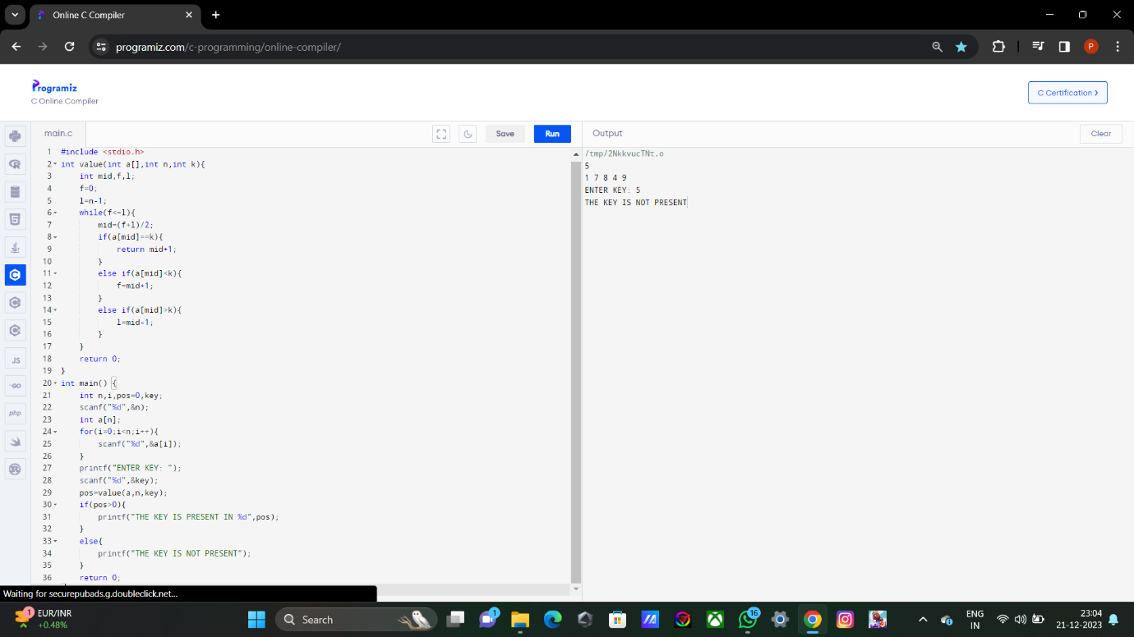

6. LINEAR SEARCH TO PRINT WITH INDEX POSITION

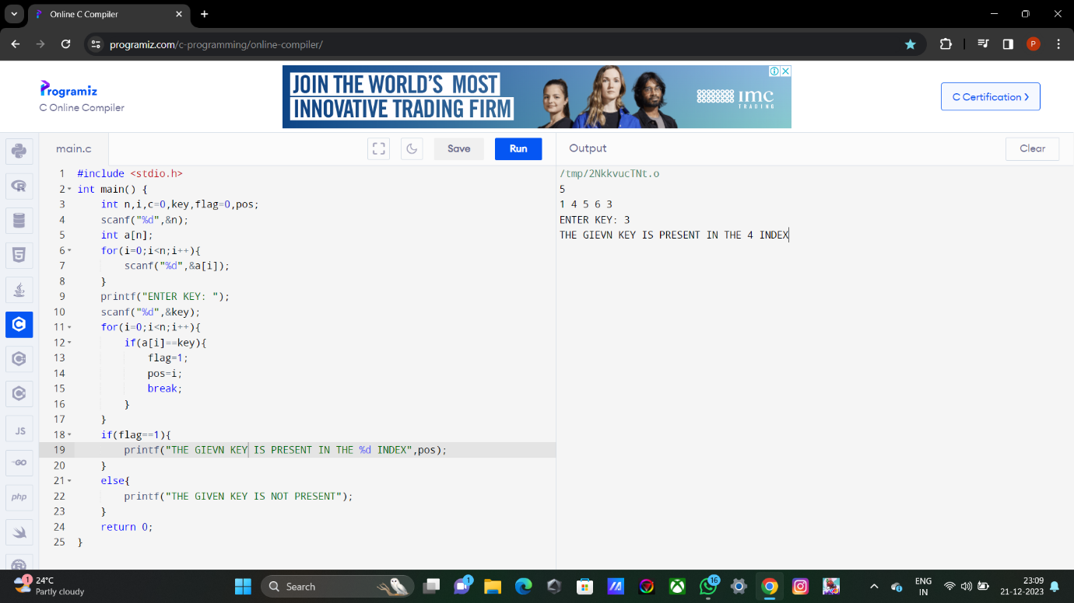

7. INSERTION OF AN KEY ELEMENT IN THE GIVEN POSITION.

